Giant Antarctic iceberg could affect global ocean circulation
Ice broken off from Mertz glacier is size of Luxembourg and may decrease oxygen supply for marine life in the area.
guardian.co.uk, Friday 26 February 2010 12.19 GMT
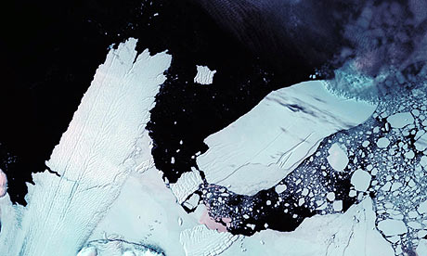
Satellite image showing 97km (60 mile) long iceberg, right, about to crash into the Mertz glacier tongue, left, in the Australian Antarctic Territory. The collision created a new 78km-long iceberg. Photograph: AP
An iceberg the size of Luxembourg that contains enough fresh water to supply a third of the world's population for a year has broken off in the Antarctic continent, with possible implications for global ocean circulation, scientists said today.
The iceberg, measuring about 50 miles by 25, broke away from the Mertz glacier around 2,000 miles south of Australia after being rammed by another giant iceberg known as B-9B three weeks ago, satellite images reveal. The two icebergs, which both weigh more than 700m tons, are now drifting close together about 100 miles north of Antarctica.
Rob Massom, a senior scientist at the Australian Antarctic Division and the Antarctic Climate and Ecosystems Cooperative Research Centre in Hobart, Tasmania, said the location of the icebergs could affect global ocean circulation and had important implications for marine biology in the region.
The concern is that the massive displacement of ice would transform the composition of sea water in the area and impair the normal circulation of cold, dense water that normally supplies deep ocean currents with oxygen.
"Removal of this tongue of floating ice would reduce the size of that area of open water, which would slow down the rate of salinity input into the ocean and it could slow down this rate of Antarctic bottom water formation," Massom told Reuters.
Mario Hoppema, chemical oceanographer at the Alfred Wegener Institute for Polar and Marine Research in Germany, said that as a result "there may be regions of the world's oceans that lose oxygen, and then of course most of the life there will die".
B-9B is a remnant of a 2,000-square-mile iceberg that calved in 1987, making it one of the largest icebergs recorded in Antarctica. It drifted westwards for 60 miles before becoming grounded in 1992. It has recently re-floated itself and rotated into the Mertz tongue.
The Mertz glacier iceberg is among the largest recorded for several years. In 2002, an iceberg about 120 miles long broke off from Antarctica's Ross ice shelf. In 2007, a iceberg roughly the size of Singapore broke off from the Pine Island glacier in west Antarctica.

